Three Drones
by Peter Griffin
Connected
Level 3
2019
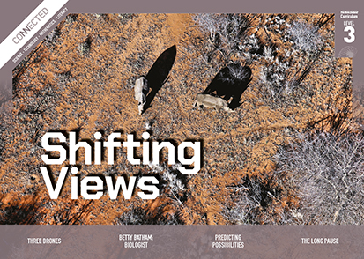
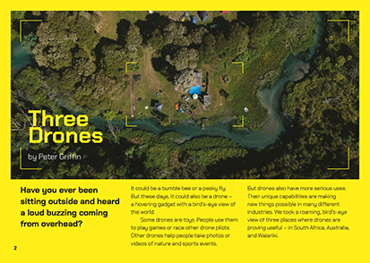

The Literacy Learning Progressions: Meeting the Reading and Writing Demands of the Curriculum describe the literacy-related knowledge, skills, and attitudes that students need to draw on to meet the demands of the curriculum.
The Learning Progression Frameworks (LPF) describe significant signposts in reading and writing as students develop and apply their literacy knowledge and skills with increasing expertise from school entry to the end of year 10.

Overview
Most students will be aware of drones. This article describes three examples of how they are used in the world of work. By demonstrating their use within three different fields, the text builds awareness of how they work, how they are used now, and how they might be used in the future. Teachers may also use the article to further prompt thinking about ethical issues around the use of drones as an example of a new technology.
A Google Slides version of this article is available at www.connected.tki.org.nz
Curriculum contexts

TECHNOLOGY: Nature of Technology: Characteristics of technology  Level 3 – Students will understand how society and environments impact on and are influenced by technology in historical and contemporary contexts and that technological knowledge is validated by successful function.  TECHNOLOGY: Nature of Technology: Characteristics of technological outcomes  Level 3 – Students will understand that technological outcomes are recognisable as fit for purpose by the relationship between their physical and functional natures.  Designing and developing digital outcomes  Progress outcome 2  Students identify the specific role of components in a simple input-process-output system and how they work together, and they recognise the “control role” that humans have in the system … | Key technology ideas  - Societal and environmental issues can influence what technological outcomes are made.  - Drones can be used in diverse environments to support many different types of work and activities.
SCIENCE: Nature of Science: Communicating in science  - Engage with a range of science texts and begin to question the purposes for which these texts are constructed. | Key Nature of Science idea  - Scientific articles are written by people who may hold a particular perspective or opinion.

ENGLISH: Reading  Level 3 – Ideas: Students will show a developing understanding of ideas within, across, and beyond texts. | Indicators:  - uses their personal experience and world and literacy knowledge confidently to make meaning from texts  - makes meaning of increasingly complex texts by identifying main and subsidiary ideas in them  - starts to make connections by thinking about underlying ideas in and between texts  - recognises that there may be more than one reading available within a text  - makes and supports inferences from texts with increasing independence.

The New Zealand Curriculum

Meeting the literacy challenges

The main literacy demands of this text lie in the technical information about drones. However, the article avoids going into too much detail on their operation, focusing more on their uses and the opportunities they create.  The structure of the text will support students to make connections and navigate some of the technical language. Following an introduction to the anatomy of a drone, the three examples follow the same structure, gradually building an understanding of the capabilities of different drones.  Some technical terms are defined or supported in the text, while others rely on the diagrams, photographs, and context. The photographs taken using the drones provide a platform for students to engage with the topic and to make connections with their prior knowledge. | The instructional strategies below support students to meet the literacy challenges of this text. For each strategy, there are links to the relevant aspect of The Learning Progression Frameworks (Reading). The signposts on each of these aspects provide detailed illustrations on what to notice as your students develop their literacy knowledge and skills for different purposes in different curriculum areas.  The following strategies will support students to understand, respond to, and think critically about the information and ideas in the text.  You may wish to use shared or guided reading, or a mixture of both approaches, depending on the reading expertise of your students and the background knowledge they bring to the text.  After reading the text, support students to explore the activities outlined in the following pages.

INSTRUCTIONAL STRATEGIES

Finding the main ideas  [LPF Reading: Acquiring and using information and ideas in informational text]  Have the students read page 2 and PROMPT them to make connections to their prior knowledge of drones and predict possible uses of their “unique capabilities”.  What does “unique capabilities” mean? What clues can we get from the text?  What are some of the things you think a drone could do that other gadgets couldn’t?  With the students, preview the text to clarify the article structure and predict what students will learn about drones. Draw attention to the three different examples. Use Google Maps or Google Earth to show the locations of the drones in South Africa, the Australian desert, and the Bay of Plenty.  LIST the students’ ideas about the use of drones for work and for recreation. They can draw on what they know, what they have just read, and what they imagine.  Organising ideas and information  [LPF Reading: Reading to organise ideas and information for learning]  Have the students work in pairs or small groups to design graphic organisers that could be used to summarise the information. EXPLAIN that we use graphic organisers to show the relationship between different facts or ideas, referring to some examples the students have used in other lessons. Have the students share their designs with each other and give feedback on their effectiveness.  Have students read the text and fill in the graphic organisers. PROMPT the students to think about the task.  What is the purpose of creating and using a graphic organiser? Has this task made a difference to your understanding of the information in this article? How did it do that? | Did you make any changes to the original design of your graphic organiser? Why?  What have you learned about the elements of an effective graphic organiser? What are some other times when this sort of technique might be helpful?  Critical thinking about the main ideas  [LPF Reading: Making sense of text: reading critically]  EXPLAIN that scientists and technologists work with facts but, like everyone, they have their biases. PROMPT critical thinking about why the writer wrote this text and the line between fact and opinion. Move the students towards an understanding that when scientists and technologists communicate, there is an element of persuasion. The writer appeals to logic but also appeals to our emotions. For that reason, we need to think critically about their purpose in writing and their point of view, rather than simply accepting everything they say.  How do you think the writer feels about drones? How can you tell? What clues do you get from reading page 2? (“bird’s-eye view” in connection with the photograph, “unique capabilities”, “new things possible”)  Let’s look at the first example. How does the writer feel about rhinos and the use of drones to monitor poaching? How can you tell? What might a poacher have to say about this?  Look at the other two examples. What is fact and what is opinion?  The writer finishes the article with a “call to action”. What is it he wants the reader to do?  How do you feel about persuasive language in a scientific article? How should we deal with it when we find it?

Meeting the literacy challenges

Using visual features for deeper understanding  [LPF Reading: Making sense of text: using knowledge of text structure and features]  Point out that there are a lot of photographs in the article. EXPLAIN that each of them has a purpose. Remind the students to read the captions to understand what the photographs show and to make connections between what is in the photograph and what is in the text. They need to look closely at the details and infer what they mean.  PROMPT the students to notice that some of the photographs were taken with drones and others were not. Have them look closely to compare the two sets of photographs.  - What can you get from a camera on a drone that you can’t get from a normal camera?  - Looking at the photographs, can you see any disadvantages of using footage from a drone?  Focus on the diagram on page 3. PROMPT the students to unpack the way the diagram works, for example:  - the numbering connects the parts of the diagram to the labels  - the names of the parts are in bold  - the explanations of the purpose of each part are in regular text.  Gradually scaffold the students towards an understanding of the different parts of the drone. You could do this by:  - giving students an image of the drone and a list of the labels and having them put the correct numbers to the correct parts (use the Google Slides content to create these resources)  - giving students cards with the names of the parts and their explanations and ask them to match the two  - playing a game where one student imagines themselves to be part of a drone and explains what they do while the others guess their name. | Dealing with scientific and technical vocabulary  [LPF Reading: Making sense of text: vocabulary knowledge]  PROMPT the students to notice that this article has many words that are likely to be unfamiliar. Give the students sticky notes to identify unfamiliar words and phrases. After the reading, DISCUSS some of these terms.  How does the writer help us to understand them?  What strategies did you use to work them out?  PROMPT the students to IDENTIFY the key terms they need to know. Have them use print or online dictionaries to check their meaning and create a shared glossary.  DISCUSS the company name Aeronavics.  Is this a real word? How do you think they made it? Why use a made-up word?

The Learning Progression Frameworks
The Literacy Learning Progressions
Effective Literacy Practice: Years 5–8

Illustrating the key ideas

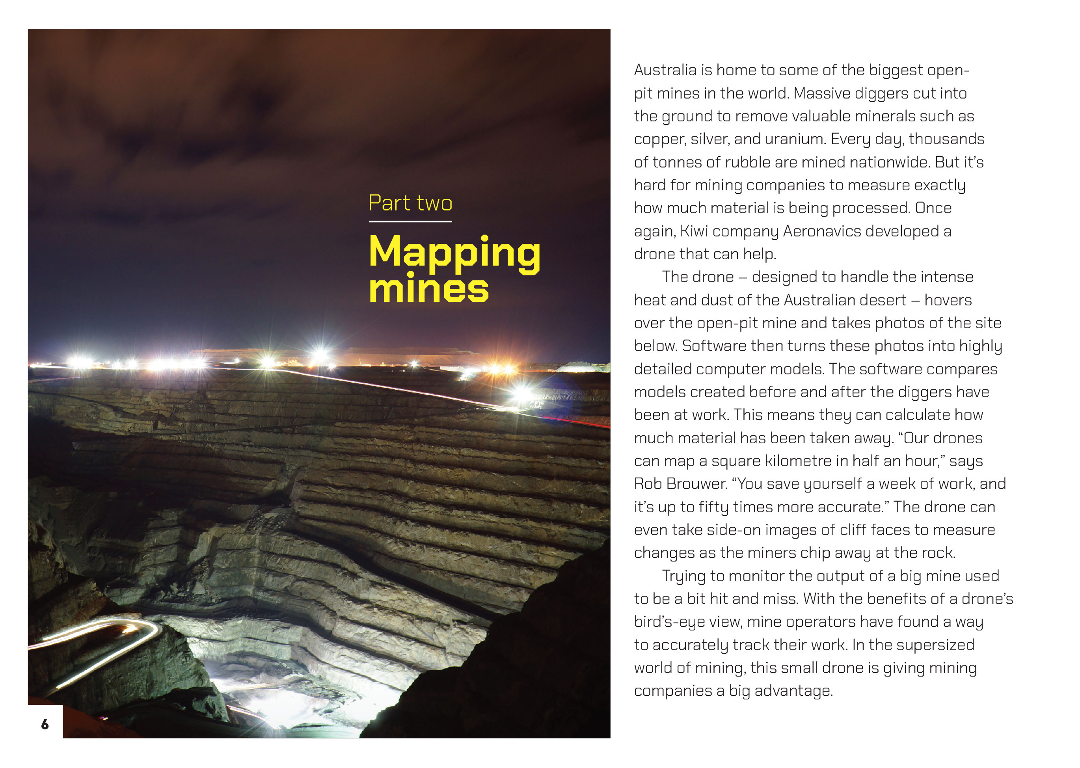 |  | Technological outcomes are recognisable as fit for purpose by the relationship between their physical and functional natures.  Societal and environmental issues can influence what technological outcomes are made.  Drones can be used in diverse environments to support many different types of work and activities.  .

Learning activities – Link to technology

Activity 1 – Diving deeper into drones  Have the students investigate one of the three examples – or choose their own example – to find out more about the role of drones to do certain work. Prompt them to reflect on their reading to identify the questions and issues they wish to explore. These might include:  - How was this work done before drones came along?  - What are the advantages of using drones in these situations?  - What could go wrong?  - How do the various parts of the drone help it to perform its task?  - What changes have to be made to enable a drone to perform a specific task?  - How does the use of this drone affect people and the environment?  - What are some other applications for this particular use of drones?  Take a jigsaw approach to this investigation so that the students learn from each other. Discuss how they can report their findings in a systematic way that makes it easy for them to compare what they discover about the various examples.  Activity 2 – Questioning our use of drones  As a class, revisit the first page of the article. Prompt a discussion about the potential negative impact of drones, as well as their positives.  In the first sentence, the writer asks us if we’ve ever been sitting outside and heard a loud buzzing overhead. Have you had that experience, or do you know somebody else who has? Did it bother you or that person? What was the concern?  Imagine we were out running the cross-country and a drone appeared overhead and started filming us all. Would you be okay with that?  Imagine you’ve gone out into the wilderness to enjoy the peace and quiet and a drone comes by delivering someone their pizza. How would you feel?  What happens if there are multiple drones operating in the same area or if they are being used in the same air space as aeroplanes?  Create a PMI chart for the students to record the positives, negatives, and interesting points about drones.  Plus Minus Interesting  Play the Science Learning Hub video from Aeronavics and have the students use it to add to and refine their PMI chart. Prompt them to respond to the statement by Martin Riegel (from 0:27 to 0:45) about the market for drones and their potential uses.  The chairman of Aeronavics says there are three market segments: military, commercial, and consumer. What do you think is the difference between these three segments? Let’s find out. | The following activities and suggestions are designed as a guide for supporting students to explore and extend their content knowledge across the learning areas. Adapt these activities to support your students’ interests and learning needs.  How would people in each of these market segments use drones? We know a bit about consumer uses, because that’s what we usually see, and we learned from the article and the video about some of the commercial uses? Do you have any ideas about how the military would use drones?  Working in groups, have the students go online to explore current uses and possible uses for drones, as well as learning about potential misuse. Have each group develop their own PMI chart. This will require them to use evidence and think critically as they debate the placement of different entries. While the students could aim for consensus, they may choose to add a fourth column for “debatable”.  When they have completed their charts, have the groups share them. Use questions such as the following to help the students think through what they have learned and identify their personal perspectives on drones. Again, encourage discussion and debate – there is no need for everyone to agree.  What are the biggest advantages in drones?  What is most problematic?  Where were our areas of biggest agreement? Where did we agree the least?  What questions do you have?  Where do you see drone technology going in the future?  How might drones change our lives?  Suggest to the students that while everybody has their own thoughts and feelings about drones, all would probably agree that they are part of our lives now. For them to be acceptable, we need rules for using them. Ask each group to use their PMI chart and the subsequent discussion to suggest a set of rules and regulations that would promote the safe and productive use of drones. Have the groups compare their rules with another group and combine their ideas in an agreed set of rules.  Explain that New Zealand already has rules, but perhaps, they are not known by everyone who uses or is affected by drones. Take the students to the Civil Aviation Authority microsite Fly Your Drone and the Airshare websites to learn about the current rules. Have them compare these rules with the ones they developed.  Do the current rules on the use of drones make sense to you? Thinking about your own discussion, can you see the reasons for them? Can you see where the official rules might be improved?  Do you think all drone users know about the rules? What about people who are impacted by drones, as in some of the examples we discussed?  If the students think the current rules could be improved, they could write to the Civil Aviation Authority. If the use of drones has been problematic in your community, students could think about how they could publicise the rules so that everyone knows about them.

RESOURCE LINKS

Science Learning Hub  Aeronavics: https://www.sciencelearn.org.nz/resources/1443-aeronavics  Falcon UAV (image): https://www.sciencelearn.org.nz/images/1750-falcon-uav  Hi tech drones copy nature’s design: https://www.sciencelearn.org.nz/resources/2352-hi-tech-drones-copy-nature-s-design  Kaikōura earthquake: https://www.sciencelearn.org.nz/resources/2312-kaikoura-earthquake  Interpine  Applying UAV / Drones on the fire line – thermal camera hotspot detection: https://interpine.nz/applying-uav-drones-on-the-fire-line-thermal-camera-hotspot-detection-2/  Practical application of UAV’s for fire: https://interpine.nz/wp-content/uploads/2016/05/Practical-Application-of-UAV-on-the-Fire-Ground-May-2016.pdf  Stuff  Drone ranger can home in on yellow-eyed penguin nests quick smart: https://www.stuff.co.nz/environment/109223418/drone-ranger-can-hone-in-on-yelloweyed-penguin-nests-quick-smart  A drone with thermal imaging technology used to spot water leaks in Waipā: https://www.stuff.co.nz/waikato-times/news/112369208/a-drone-with-thermal-imaging-technology-used-to-spot-water-leaks-in-waip  Thermal imaging camera on drone spies source of year-long mystery water leak: https://www.stuff.co.nz/business/113123772/thermal-imaging-camera-on-drone-spies-source-of-yearlong-mystery-water-leak  Drone flies in to watch NZ farm’s flock: http://www.stuff.co.nz/business/farming/agribusiness/9335825/Drone-flies-in-to-watch-NZ-farms-flock | Other sources  Aeronavics New Zealand – industrial aerial robotics: http://aeronavics.com/  Airshare: NZ drone rules: https://www.airshare.co.nz/rules  Civil Aviation Authority: Unmanned aircraft – drones: https://www.caa.govt.nz/unmanned-aircraft/drones/  Fly Your Drone: https://www.flyyourdrone.nz/  Imperial War Museum: A brief history of drones: https://www.iwm.org.uk/history/a-brief-history-of-drones  New Zealand Government: Taking flight – An aviation system for the automated age (drone integration paper, July 2019): http://img.scoop.co.nz/media/pdfs/1907/Taking_Flight_an_aviation_system_for_the_automated_age.pdf  Ministry of Transport: Drones: https://www.transport.govt.nz/air/unmanned-aircraft-systems-or-drones/  Curious Minds: Stamp out those stinkin’ fruit pests! https://www.curiousminds.nz/stories/stamp-out-those-stinkin-fruit-pests/  UAVNZ: New Zealand drone firm assists South African conservationists’ fight against rhino poachers: https://www.uavnz.com/front-news/1713/  Know before you fly: Unmanned aircraft guidance for users (US): http://knowbeforeyoufly.org/  WVLT8: Oak Ridge middle school students learn drone technology: https://www.wvlt.tv/content/news/Oak-Ridge-middle-school-students-learn-drone-technology-502015741.html  ScienceDaily: New foldable drone flies through narrow holes in rescue missions: https://www.sciencedaily.com/releases/2018/12/181212104618.htm?utm_source=feedburner&utm_medium=email&utm_campaign=Feed%3A+sciencedaily%2Ftop_news%2Ftop_science+%28ScienceDaily%3A+Top+Science+News%29  GEO awesomeness: Top 5 most futuristic drone application ideas that already exist: http://geoawesomeness.com/top-5-futuristic-drone-ideas-that-already-exist/  TKI ESOL Online: Jigsaw reading: http://esolonline.tki.org.nz/ESOL-Online/Planning-for-my-students-needs/Resources-for-planning/ESOL-teaching-strategies/Reading/Jigsaw-reading

